|  |  |
| --- | --- |
|  | **Cyber Physical Systems**  **Assignment Report**  Version No.1.0 |
|  |

Table of Contents

1.0 Contribution Table 3

1.1 Group’s Contribution: C2, A2 3

2.0 Main Text: C2 3

2.1 Problem Statement 3

2.2 Block Diagram 4

2.3 Approach & Algorithm 4

2.4 Result and Conclusion 4

3.0 Main Text: A3 4

3.1 Problem Statement 4

3.2 Block Diagram 5

3.3 Approach & Algorithm 5

3.4 Result and Conclusion 5

4.0 References 5

# Contribution Table

## Group’s Contribution: C2, A2

|  |  |  |  |
| --- | --- | --- | --- |
| **Serial No.** | **Name** | **ID No.** | **Contribution** |
| 1 | Ashish Ranjan | 2021CT93023 |  |
| 2 | Sandhya Shanmugam | 2021CT93031 |  |
| 3 | Ritu Bala Rai | 2021CT93003 |  |
| 4 | Sriya Sengupta Kabiraj | 2021CT93009 |  |

# Main Text: C2

## Problem Statement

**Single Gas Cylinder Monitoring System:** Load Sensor connected to Arduino Uno, Data collected by Arduino Uno is sent to rest of the network through Gateway Node (NodeMCU), Mobile APP and web dashboard using Blynk, ThingSpeak cloud for data analytics

## Block Diagram

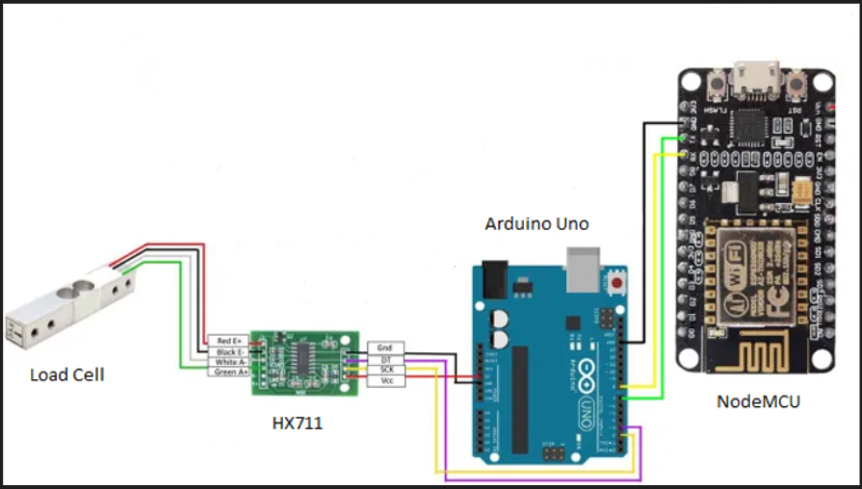

Figure 1.0

## Approach & Algorithm

We have used Xcluma load cell which has a maximum capacity of 20kg. This load cell uses a wheatstone bridge to measure the load. When some weight is added to the load cell, the wheatstone bridge sends a very weak signal. To amplify this signal, we connect an HX711 board to the load cell. This board is in turn connected to the Arduino controller. The Arduino controller is also connected to NodeMCU board which sends data to Blynk & Thingspeak cloud over Wi-Fi. We have also connected an LCD display to show the weight of the item on the load cell.

## Result and Conclusion

The weight of the item can be viewed in Thingspeak, Blynk as well as the LCD screen.

# Main Text: A3

## Problem Statement

**Interfacing Temperature Sensor**

## Block Diagram

|  |
| --- |
|  |

Figure 3.0

## Approach & Algorithm

We have a DHT 11 module temperature sensor connected to Arduino. It senses the temperature around and send it to Arduino. Arduino in turn displayes the temperature on the connected LCD display.

## Result and Conclusion

Temperature is displayed on the LCD

# References